SENSORY INTEGRATION BRIEFING: AUDITORY PROCESSING DISORDER (APD)
Today I’m going to go over what an auditory processing disorder (APD) is, what it will look like in the classroom and at home, and what some of the sensory diet strategies are which you can use to see if the situation improves. As always, the goal is to help the students you support to be in the best possible place to learn – feeling calm, organised and energised. The first step for you to be an agent of change for them is to recognise what might be getting in the way of participation.
Picking up the sound signal
When we hear, vibration (from the air molecules of the sound wave battering against the ear drum) passes along the little bone chain of the middle ear and from there to the entrance of the inner ear. This creates a wave movement of the fluid inside the inner ear. As the wave moves over the rows of tiny hair cells inside the cochlea, the hair cells move, and the movement triggers an electro-chemical response.
That electro-chemical signal is pushed across the synapse to the auditory nerve, and then pushed again across the next synapse to the next part of the pathway and so on, until it finally reaches the auditory cortex which is the part of the brain roughly just above your ears on both sides of your head.
From there, how much sense you can make of the sound is going to depend on the connections that you have grown between your brain cells – the neural network. As we have talked about a lot, what causes that neural network to grow is your experience of sensory events over time.
When we talk about APD, we don’t mean someone who is deaf or hard of hearing in the classic sense. Their ears, in effect, work fine. The difficulty is in the message moving from the inner ear (or cochlea) to the auditory nerve; from there along the auditory pathway to the brain; and then how the brain manages and understands the information. For lots of people with APD, their hearing test is normal – the APD doesn’t affect their access to sound, it affects what use they can make of sound, and how they can understand speech meaningful environmental sounds like a whistle being used to indicate break time has finished.
There is a bit of variation in how the term APD is used by different professions. For most audiologists, APD (sometimes they use the term Central APD, CAPD) a difficulty which happens after the signal gets to the brain stem, and with what happens within the brain once the information is there. In comparison, they would call problems with getting the message from the cochlea to the brainstem by a different acronym: Auditory Neuropathy Spectrum Disorder (ANSD). For audiologists, there’s a clear and different route of diagnosis for ANSD and APD, so it makes sense to call them different things – I’ll explain the difference between them more fully in a later blog post. SI therapists tend to call the whole lot APD. In any case, the effect on listening and understanding in the classroom, and the actions you can take to help, will be pretty similar for both diagnoses.
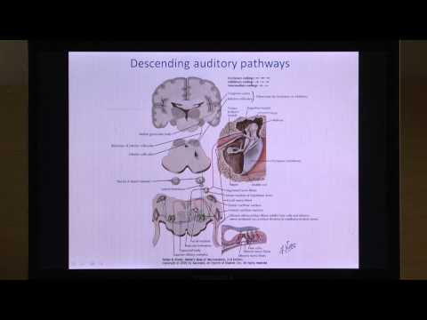
Here’s a short video which talks about some of the brain areas involved in auditory processing.

What does APD look like in the classroom?
APD makes it very difficult to home in on the sound that you do want to listen to when there are other sounds at the same time. It makes it very difficult to discriminate between sounds. Students with APD struggle to listen or to follow spoken information when there is any background noise, even low levels of background noise.
As a consequence, you might see focus and attention deteriorate more quickly in learning activities where there is background noise – for example, in small group work, where there is music or a video playing in the background, or where there is a sound outside the classroom like people talking in the corridor or the sound of someone mowing the grass.
Students will be slower to notice and respond to new sounds, slower to respond to their name than others, and find it hard to locate where sounds are coming from (so they tend not to look at the speaker quickly, or get overwhelmed or lost in group discussions or conversations if they lose track of who is speaking).

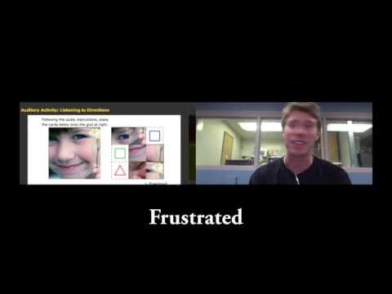
As students will find it very hard to hear and understand in situations where there is an echoing environment, or lots of background noise, you might have reports that behaviour outside the classroom – for example on visits to a supermarket or swimming pool – is significantly worse than in the quieter environment at school.
People might mistake the student not being able to hear and respond to being called or told to stop as running away if they don’t realise that it is APD. You will get reports that the student is deliberately “ignoring” someone, or isn’t paying attention.

Because auditory processing – attaching meaning to the sounds the ears pick up – is fundamental to a wide range of other cognitive skills, there can be far-reaching impacts of APD. Developing mature attention control, auditory memory, sequencing skills and receptive and expressive language structures all rely on auditory processing. The way you develop your speech sounds relies heavily on how you hear the sounds around you – if your experience of speech that it sounds distorted or unclear, that can affect how easily you develop clear sounding speech yourself.

What can you do to support learners with APD?
- Manage background noise
The number one priority is to look at background noise in the classroom. Some background noise sources are relatively easy to manage – for example, always switch off the projector when you aren’t actively using the whiteboard; keep the classroom door closed if there is traffic in the corridor; and keep the windows shut when there is noise outside (even if it’s warm).

Managing the noise made by other learners can be harder. For general hubbub and chatter, it’s important to keep reminding students when it’s appropriate to talk and when not. I have found the Chatter Tracker useful. It’s also important not to shout over the noise (even to tell people to keep the noise down!), so think about having a non-verbal signal for “quiet down, please”. For group work, or where some of the students are being supported in their learning by a TA talking them through a specific task, you might look at where the student with APD is positioned, think about using a quiet room or – if there isn’t a suitable break out space – trying to keep one area of the classroom quieter. Similarly, if you have learners in your class who are involuntary noise makers, you might want to consider breaking the groups by loudness levels, and see if you can locate the quieter group in a separate space (you might, for example, need to run the learning activity in two shifts).
Personal FM systems are very successful for people with APD. They allow the listener to have good access to the teacher’s voice using a transmitter and an earpiece, even in noisier environments. If you have soundfield system in your classroom but you don’t use it regularly – for goodness’ sake, do! It might be that you want to find a different, more comfortable or less intrusive mic/transmitter which you feel comfortable using. In any case, it will protect your voice too, and no doubt you’ll thank me when you don’t end up with a hoarse and scratchy “Old Teacher Voice” at the end of your career.
- Look at the acoustics of the room
Sound bounces off hard surfaces creating a reverb or echo, which can make listening much harder for learners with APD. In these days of greater emphasis on infection control and wipeable surfaces, much of the soft fabrics from the classrooms and other areas of the school have tended to be replaced by hard and shiny surfaces, so it’s useful to have a good look at how sound-friendly the classroom is. Consider acoustic panels on the walls, rubber feet on the bottom of chairs and tables, putting a cloth over the table before an activity (one which you can stick in the washing machine afterwards!), silicon placemats on desks, and making sure windows have blinds or curtains. If you have a high ceiling, see if you can suspend mobiles or fabric banners (you’ll need to consider fire requirements, and also keep anything dangling above the usual eyeline of your learners).

If you have access to a grant or a capital projects pot of money, you might consider a formal acoustic review of the school buildings. Lots of companies offer them – for example, PC Werth who also supply soundfield and FM systems. David Canning’s study on the changes a school in Essex experienced using improved room acoustics strategies is worth a read. Not only were there improvements in engagement and attainment, but there were emotional and psychological benefits for the staff and students too. After all, who doesn’t want to work in a calm environment!

- One sound signal at a time
Think about your teaching style, and the way you use resources. Ideally, you want to aim for there being one sound source going at a time, and for that sound source to have visual back up.

In practice, this will mean making sure that you mute or pause a video or app before you give verbal instructions or clarifications. You’ll turn off background music on apps, and choose videos which don’t have major music and special effects going on behind the voice. If you use “end of the day” music, you let the music finish, or mute it, before you give any instructions. You’ll work with the TAs in your class to make sure that they don’t talk when you’re talking, either when they are giving differentiated instructions for a learner or talking to each other. You’ll choose videos where there is a person’s face rather than a voice over, wherever possible. You’ll make a conscious effort to include Makaton signs or gestures for key words all the time. And you’ll tap in to our natural hot-wiredness for our own names by using the learners’ names a lot when you are teaching, to keep them re-focusing on your voice and what you are saying.

Most classrooms go through louder and quieter rhythms throughout the day, and certainly I’m not suggesting that you need to creep around like ninjas… but if you are aware of the impact of noise on the participation of learners with APD, and consciously try to include strategies to support their listening, you’re doing great work for the people you support. Don’t forget to record the strategies that you are using and measure if they have an impact for the learner’s progress record (I’ll be posting a blog soon about different ways of recording and monitoring progress in a Sensory Diet).

Have fun! And keep your teaching SENSATIONAL!
Amy

