SENSORY INTEGRATION BRIEFING: TACTILE DEFENSIVENESS
Today we’re thinking about the impact on classroom participation and behaviour for learners who are struggling with an over-responsive tactile processing system, which you sometimes hear described as Tactile Defensiveness. We’ll think about some of the potential flashpoints across the school day for learners with tactile over-responsivity, and a few sensory diet strategies which you can try out to see if it improves the situation.
Tactile sensation is picked up by receptors in different layers of the dermis (skin). There are different kinds of receptors for different kinds of stimulation including light, tickly touch; temperature; skin stretch and pain. The receptors for deep pressure contact are also embedded in the skin, but at a much deeper level. There greatest concentrations of tactile receptors are in the skin of the hands and fingers, mouth and face, and around the genitals. You may remember from your science classes the idea of the “homunculus” – a visual representation of which parts of the body are more densely packed with sensory receptors.
There is a different nerve pathway for touch around the head, face and neck – the trigeminal nerve pathway, which I’ll talk more about in a later briefing, as it is particularly involved in the sensory component of eating. The fact that there’s a different pathway for the head and neck from the rest of the body means that some people can have a very extreme response to touch around their head, but be less bothered about being touched on the arm or the back, or vice versa. Typically, though, if you struggle to manage touch without your limbic (survival) system being activated, that’s likely to be everywhere across the body.
Tactile defensiveness is part of the Sensory Modulation Disorder diagnostic category of Sensory Processing Difficulties. Current theory suggests that for people who over-respond to sensation, the difficulty might be with “gating” at the synapse between the receptor cells and the first part of the nerve pathway. Although we’re thinking just about touch receptors today, the idea would be the same for every sensory system and nerve pathway which was over-responsive.
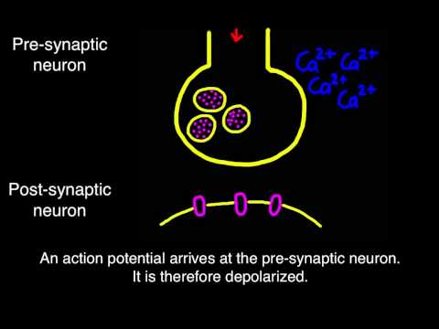
Just to refresh your memory, here’s a video which shows how the electro-chemical signal in a normally functioning receptor cell crosses the synapse and begins the lightning-quick journey to the brain.
You can see that the action potential – the electrochemical “message” – is pulled into the synaptic cleft from the receptor cell, and then pulled into the receiving dendrite of the nerve cell through the ion channels – the gates are opened. Once the balance of neurotransmitters and electrolytes/ions in the synaptic cleft changes, the ion channels on the receiving end block the incoming neurotransmitters, and the signal is pulled down towards the cell body ready for the next firing in the chain – the gates are closed. Consider what might happen if that gating process doesn’t happen efficiently and the switch off didn’t happen in the way it does normally. The receiving nerve may continue to fire, to send the message that the stimulus is still actively being received, or is considerably greater in intensity.

Tactile defensiveness flashpoints in school
Wearing school uniform and shoes consistently. If a student struggle to cope with touch, anything against the skin will cause the receptor cells to fire. They might find the feeling of their clothes against their skin heavy, rough and chafing, and even painful. It would make internal sense, therefore, to try and take off your clothes if they are causing you discomfort. Every behaviour has an internal logic, even if it’s not obvious from the outside. Seams and labels may be scratchy against their skin, and they might insist on wearing things inside out so that they can’t feel them, or with shirts untucked from the waistband so that the uncomfortable fabric isn’t rubbing against their skin. They might take off their shoes all the time. They might pull down their underwear if it’s too tight against their body.
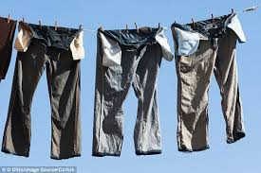
If they are doing this because it’s too uncomfortable to be able to bear, just putting the clothes and shoes back on, or trying to teach the behaviour expectation of keeping clothes and shoes on all day, is likely to be time-intensive and not very effective. Think of it this way – if I offered you a token to have a beer at the end of the week if you wore sandpaper underpants all day, you’d have to be really, really, really motivated by beer to put up with the discomfort. You might notice that issues with clothes can be heightened at start of a new school year, when new clothes haven’t been washed enough times to be soft enough for to cope with, and perhaps what is sometimes interpreted as the learner “buckling down” and complying might be because the texture of the school uniform is changing over time. Similarly, the end of the school year can also be tricky for uniform compliance if the student has grown and waistbands, collars and seams that used to hang away from the body are now much tighter.
Wearing hearing aids, glasses, splints and trachie covers. I’ve talked quite a lot in the past about the survival system – the crocodile brain (I’ll make sure I record a crocodile, cat and monkey brain refresher section on the website soon). The survival instinct is strong. If your brain decides you are at risk, it is incredibly hard to ignore it. From the outside it seems obvious that there is more to gain from wearing a hearing aid or glasses in order to be aware of your surroundings and safer, but internal logic dictates that the most dangerous thing around is whatever is brushing against your skin, especially if you can’t see it. And the longer-term value of medical equipment and orthotics won’t even factor in the face of an immediate perceived threat.
A strong proprioceptive programme first and foremost is needed, to try and reduce the crocodile brain reaction, and then tie your reward-based behaviour strategies to active selection (rather than passive tolerance of the device when distracted by something else) of the equipment. If the equipment isn’t being worn, keeping it in eyeline and building up familiarity with its sensory properties adds to the contextual information which can make it more acceptable and less anxiety-provoking.
Snacks and lunches. For many learners with over-responsive tactile systems, putting something unfamiliar in their mouth is unmanageable. They are likely to have a clearly defined range of acceptable textures and temperatures, which means they are likely to have reduced their diet to a smaller range of familiar foods, and specifically foods which don’t change in texture once you put them in your mouth. We sometimes talk about kids being on the “beige diet”, as the most common safe foods are soft boiled pasta, white bread, bland cheese or yoghurt, plain Pringles, McDonalds fries and similar foods. Food restrictions cause a huge amount of stress and anxiety for parents, and schools often feel under pressure to include targets around increasing the type or amount of foods that students will try.
When you are thinking about this from a sensory perspective, you’ll see straight away that the very worst time to be exploring new textures and temperatures with their inherent perceived threat to the crocodile is at a meal time, when the priority is to get enough calories for energy, and where the last thing you need is stress hormones running the show. We’ll think more about feeding and food issues at a later date, but for now, being aware that trying to push a learner to “just try a bit” of a new food is a sandpaper underpants experience is a good insight!

3 Sensory Diet Ideas to Try
When you put together individualised sensory diets for learners with tactile over-responsivity, you’ll be thinking of providing opportunities as part of the learner’s everyday activities where the tactile challenge moves from hard, large, dry and distal (furthest away from the body) to soft, small, slippery and proximal (closest to the body), with the individual guiding each change as they acclimatise. You are not going to slop a dab of gloop on a student’s cheek to start off with, unless you’re looking to traumatise them. Make sure everyone working with the student knows this!
You might start off, for example, using wooden or plastic bricks which the learner has to move from one area to another, then put their hands into a box of wooden bricks to pull out the equipment they need for the next task in hand. Once they can do that with confidence, you’ll be looking at changing ONE sensory property at a time – so you might change the size or colour of the bricks, or wrap them in a towel and put them in the fridge before you use them so that the temperature of them is slightly different. If your first choice of equipment doesn’t feel safe to the learner, you can provide tools for them to interact with it (for example a long-handled wooden spoon, kitchen tongs). Change just one sensory property at a time. It can be really helpful to plan in advance what those changes will be, and make a list so that you can measure progress.
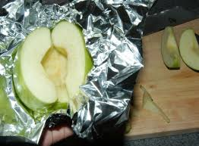
- Lucky Dip. Find any way you can to encourage the learner to get something they need from inside a wrapping or box or bag of something else. Perhaps start off with having the pencils they need sticking out of a tub of rice. Or wrap part of their snack food in foil, so they have to remove that before they can get to the snack. When that is successful, gradually move to retrieving wrapped snacks out of a box of cereal, or pencils which are buried in dried lentils.

- Squeezing. Find as many activities as you can which require the student to squeeze, squash and knead as part of the learning activity. It provides a massive amount of proprioceptive input which is going to be calming and organising, and will be activating those deeper pressure receptors (which contribute to feeling calm) as well as the light, tickly touch receptors which are closer to the surface of the skin. Start with drier and harder textures such as bread dough kneading rather than sloppier textures like papier mâché. If it’s still too challenging, start with cutting through dough using a tool like a dough scraper.

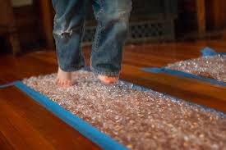
- Bubble wrap leading to self-massage. Popping bubble wrap, with a tool like a rolling pin to start if necessary is a great way in for the student to feel safe about different textures. Start with popping the wrap between fingers, then lay the wrap over their palm or arm, then calf, then foot and encourage them to pop the bubbles by pressing down into their skin. You might encourage them to stand (with socks on) on the bubble wrap, and see if they might also try to press down on it with a bare heel then a bare foot. When that’s acceptable, you’re ready to start creating some bubble wrap stepping stones or pathways, perhaps with different textures underneath like wet sand…

Don’t forget to record the strategies that you are using and measure if they have an impact for the learner’s progress record.

Have fun! And keep your teaching SENSATIONAL!

Amy

